ABIRAMI K

230701008 CSE-A

EXP 3

EXP 3A: REVERSE A NUMBER

PROGRAM:

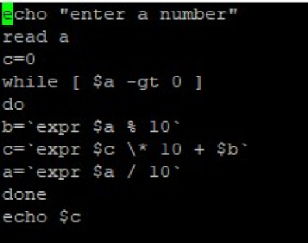

OUTPUT:

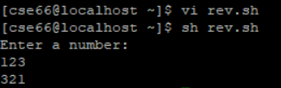

EXP 3B: FIBONACCI

PROGRAM:

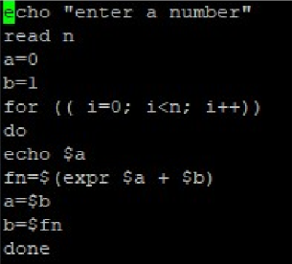

OUTPUT:  
